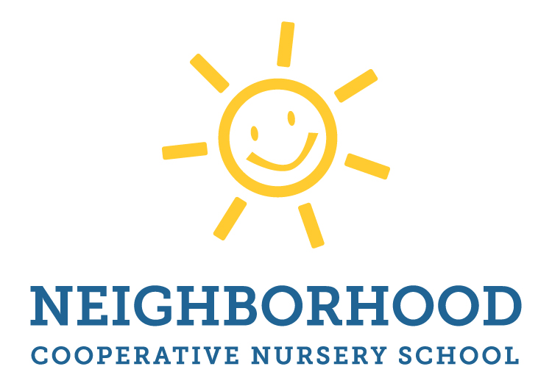

2018/2019 Older Four’s Optional Day
Tuesdays from 12:00-3:00

We offer a 4th day option to our older fours programming taught by Ms. Orsenigo. The class meets from 12-3 and is meant to complement the four’s regularly planned curriculum
The cost of the full year is $1,300. If you would prefer to sign up later in the fall, or even in the winter or spring, the cost will be prorated. This class is open to all 12 children in the Older Four’s class so no lottery will be needed.

- Yes, I would like to enroll in the Tuesday PM Older Four’s Class.

Child’s Name:____________________________

Start Date:_______________________________

__________________________________________ __________________
Parent Signature Date

